**CHAPTER III**

**PROBLEM ANALYSIS**

**III.1 Usefulness of Oculus Rift in the real world**

There are many usefulness of Oculus Rift, this tool help human to make works more easy.

Here the example of Usefulness :

1. Architecture Engineering

With Oculus Rift, Architecture can create a building or interor design with the real technology that make the Architecture feel the real room / real building.

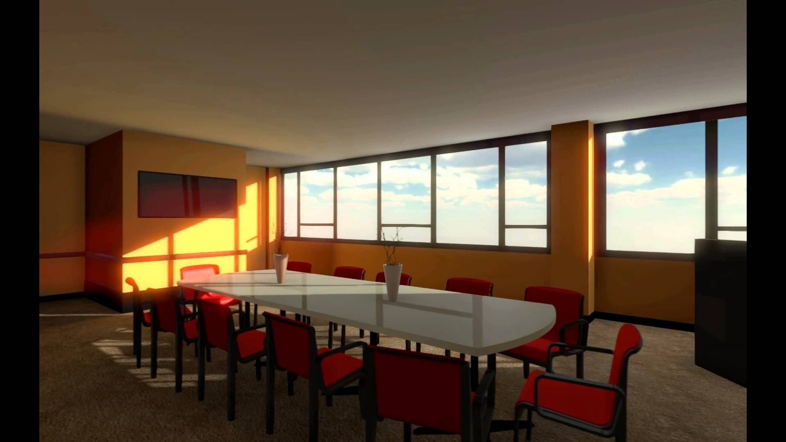

Figure 3.1 Dining Room in Virtual Reality

(REF: <http://youtube.com>)

1. **Business**

With Oculus Rift, a business man shouldn’t need bring their car to the mall or any exhibition place again. They just need bring oculus rift and can show their product in Virtual Reality technology. So the buyer will know any information of the product.

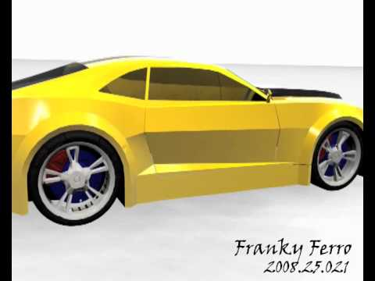

Figure 3.2 3D Car Model

(REF: <http://youtube.com> )

(REF: <http://youtube.com>)

9

1. **Entertainment**

With Oculus Rift, you can play games that bring you the real sensation like in the real world.

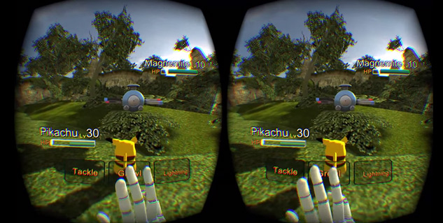

Figure 3.3 Pokemon Game on Oculus Rift

(REF: <http://megames.com>)

1. **Medical & Education**

With Oculus Rift, any College Student who take faculty of medical will be easy to create or learn body’s anatomy which can rotate anywhere. Student also can see the earth from the sky, create structure of molecule, and study about the planet solar system.

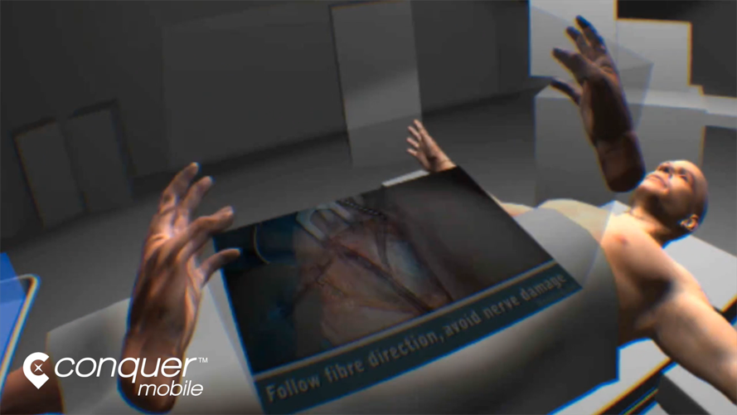

Figure 3.4 Medical Education Game on Oculus Rift

(REF: [http: //conquermobile.com](http://conquermobile.com))

10

1. **Military**

Now Oculus Rift is used by Military to free fall parachute training,laying areas of military operations, which will be used to put the troops, or even used as a guide for smart missile (missile).

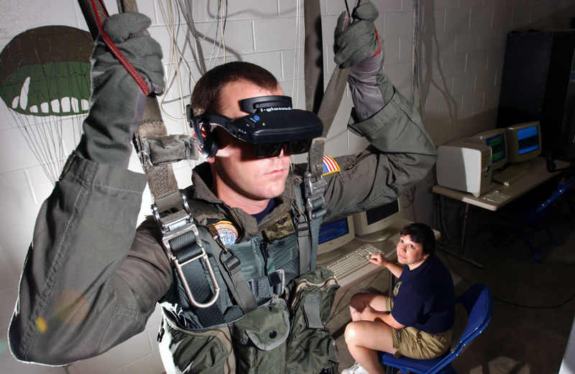

Figure 3.5 U.S Soldier trying parachute training using Oculus Rift

(REF: [www.cs.unc.edu](http://www.cs.unc.edu))

1. **Art & History**

Oculus Rift can show the visual of museum which have any historical item. Oculus Rift also can show all the past history of the building which could be engineered in 3D. This is good for our children in the future.

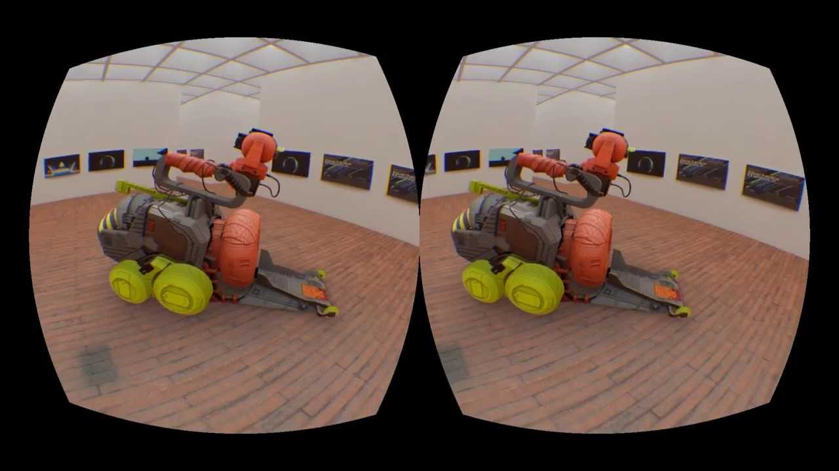

Figure 3.6 The Swedish Virtual Reality Museum on Oculus Rift

(REF: [http://](http://itunes.apple.com)youtube.com)

11

**III.2 Impact of Oculus Rift**

Besides advantages of Oculus Rift, there must be disadvantages that will be obtained when use Oculus Rift.

1. **Health**

This technology will be affect our health. If we play game too long, our eyes will be tired and our eyes will be nearsighted. And your hearing will be damaged due to the effects of the use of a headset that too often. The use of a headset that is too often also will cause a lot of bacteria in our ears. And your body will be weary because the activity is too monotonous.

1. **Labor**

Before this technology founded, if we want to see a historical objects, pictures or other heritage we should go to the museum. Imagine if people doesn’t want to go to museum and prefer to buy and use Oculus Rift. People who work on the museum will be stopped because the museum company didn’t have any income.

1. **Addicted**

Playing a game is like smoking. If we can’t control ourselves, we will be addict to playing a game. This is horrible for us, if our child playing game with Oculus Rift and they be addict. If they smart, they won’t affect their score at school. But how about if they lazy? It will affect their score at school. So, Parents must control their children when playing a game which use Oculus Rift.

12